University of Technology, Jamaica

Faculty of Engineering and Computing

School of Computing and Information Technology



Module: Advanced Programming

Module Code: CIT3009

Authors: Joel Mason, Kemar Christie, Monique Levy and Christo Thomas

Title of Paper: Java Haulage and Trucking (JHT) Group Project

Teacher: Mr. Christopher Panther

Date: March 29, 2024

**Java Haulage and Trucking (JHT) User Manual**

**Overview**

JAVA Haulage and Trucking (JHT), a prominent haulage contracting company operating in Kingston and Mo. Bay, Jamaica, stands at the forefront of delivering reliable and timely services to numerous companies across parishes. However, with the evolving landscape of business processes, JHT recognizes the imperative need to transition from manual, paper-based systems to a modern, digitized framework. In pursuit of this transformation, we recommend and implement a tailored system aligned with their office protocols. This system will cater to the diverse needs of their administrative staff and contractors, enhancing their capabilities in managing customers, payroll, trips, and orders efficiently. By embracing technology, JHT aims to streamline operations, optimize resource utilization, and elevate customer satisfaction, solidifying its position as a leader in the haulage industry.

**Application User Interface**

**Figure 1. Login Screen**

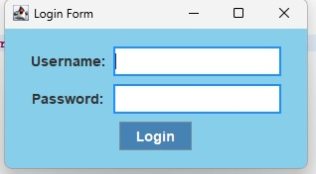

The main window of Java Haulage and Trucking (JHT) provides access to distinct functionalities based on the user's login credentials, ensuring tailored experiences for different roles within the system. With two separate login options available, users can log in using their respective credentials to access specific features:

1. **Superadmin Login (Username: superadmin, Password: superadmin)**

Upon logging in with superadmin credentials, users gain access to a comprehensive Staff Panel interface. This interface offers full visibility and control over all system functionalities, allowing superadmins to manage staff, oversee operations, and access privileged settings.

1. **Admin Login (Username: admin, Password: admin)**

Alternatively, logging in as an admin grants users access to all system features except the Staff Panel. Admins have authority over various aspects of the system, including customer panel, trip/order panel, route panel and generating report functionalities.

By providing distinct login options, Java Haulage and Trucking (JHT) ensures that superadmins and admins can efficiently perform their respective duties while maintaining appropriate levels of access and control within the system.

**Figure 2. Main Screen**

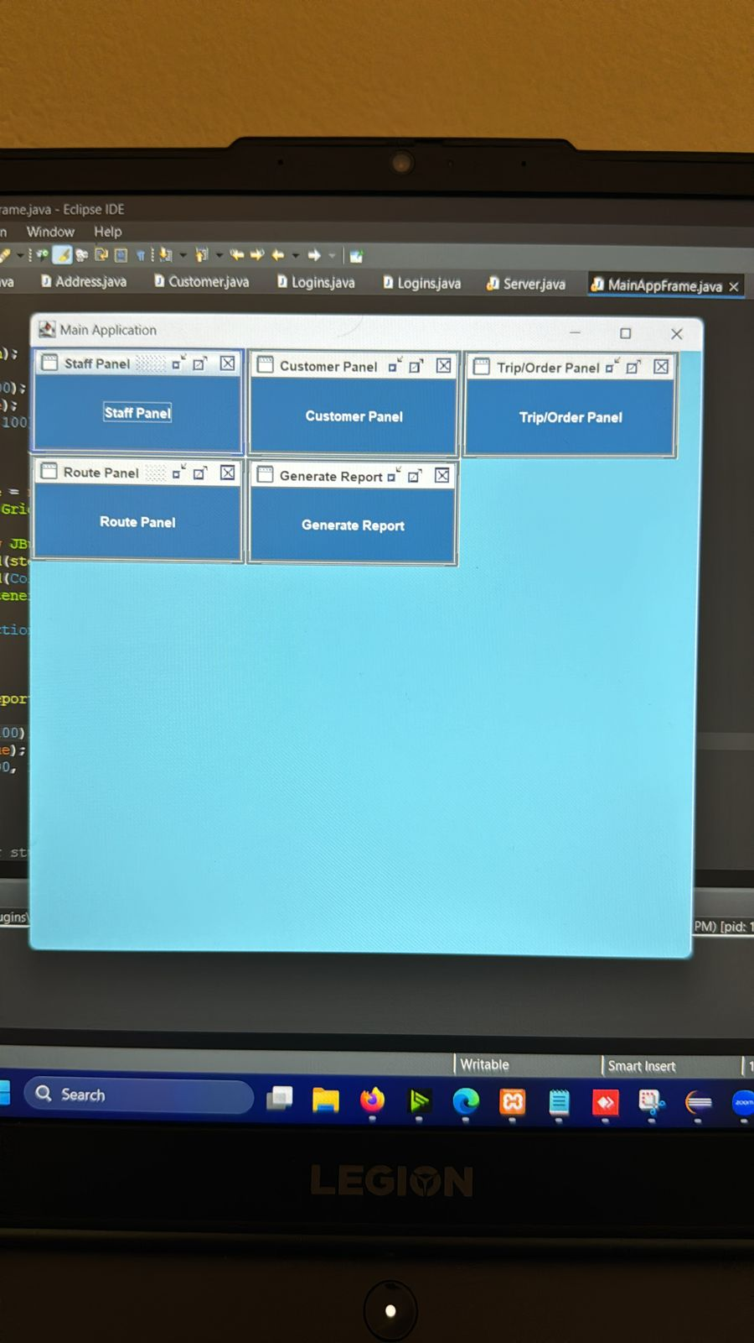

The main window for Java Haulage and Trucking (JHT) acts as the primary interface for accessing the program's many operations and features. When users activate the program, they are met with an intuitive design that allows for easy navigation and rapid access to critical capabilities. Users may utilize this window to move between numerous modules and complete critical activities. The main window provides a user-friendly environment for traversing between staff panel, customer panel, trip/order panel, route panel and generating report.

**Figure 3. Staff Panel**

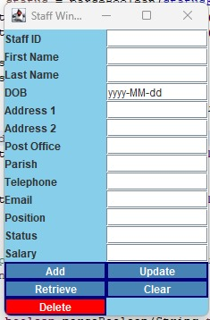

The Staff Panel screen serves as the central hub for managing staff information within the JAVA Haulage and Trucking (JHT) system, providing administrative staff with a comprehensive platform to oversee and maintain personnel records. Upon accessing the Staff Panel, users are greeted with an intuitive dashboard offering an at-a-glance overview of critical metrics. The interface presents staff details in a structured format, including first and last names, date of birth, contact information, position, and salary.

Super Admin can effortlessly navigate utilizing:

* Add new staff
* Update previous staff information
* Retrieve staff information
* Delete outdated or redundant staff from the database
* Clear screen

specific staff details to the database. With its user-friendly design, robust security measures, and comprehensive features, the Staff Panel empowers administrative staff to efficiently manage the human resources of JHT, promoting organizational efficiency and effectiveness.

**Figure 4. Route Panel**

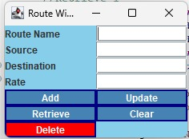

Upon accessing the Route Panel, users are presented with intuitive functionalities enabling them to:

* Add new routes
* Update existing ones,
* Retrieve route details for reference
* Delete outdated or redundant routes from the database
* Clear Screen

Each route entry encompasses crucial information such as source and destination addresses, distance, estimated travel time, and any pertinent notes or specifications. Through its user-friendly interface and robust database integration, the Route Panel streamlines route management operations, enhancing organizational productivity and optimizing transportation logistics for JAVA Haulage and Trucking.

**Figure 5. Customer Panel**

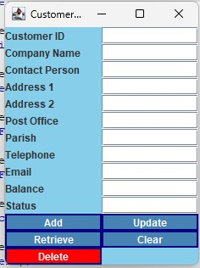

The Customer Panel enables users to perform essential functions such as

* Adding new customers
* Updating existing records
* Retrieving customer details for reference
* Deleting outdated entries
* And clearing the screen for enhanced usability.

Each customer entry encompasses vital details including Customer ID, Company Name, Contact Person, Address, Telephone, Email, Balance, and Status. The Status field allows for easy identification, while the Balance field tracks outstanding balances, automatically flagging accounts if balances remain unpaid for over 30 days. Through its user-friendly design and robust functionality, the Customer Panel streamlines customer management operations, enhancing organizational efficiency and ensuring seamless customer interactions for JHT.

**Figure 6. Trip Order**

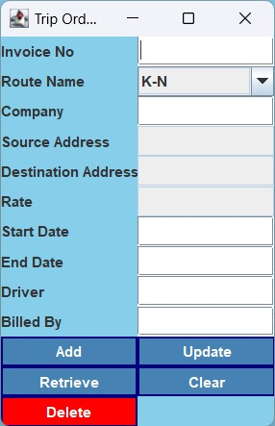

The Trip Order Panel within the JAVA Haulage and Trucking (JHT) system offers administrative staff a centralized platform to manage trip order details efficiently. This comprehensive panel enables users to perform essential functions such as:

* Adding new trip orders
* Updating existing records
* Retrieving trip details for reference
* Deleting outdated entries
* And clearing the screen for enhanced usability.

Upon accessing the Trip Order Panel, users are presented with intuitive interfaces that facilitate seamless data entry and retrieval. Each trip order encompasses vital details, including:

* Invoice Number - Unique identifier for the trip order.
* Route Name - Name of the transportation route.
* Company - Name of the company associated with the trip.
* Source Address - Starting location of the trip.
* Destination Address - Final destination of the trip.
* Rate - Monetary amount associated with the trip.
* Start Date - Date and time when the trip commences.
* End Date - Date and time when the trip concludes.
* Driver - Name of the driver assigned to the trip.
* Billed By - Name of the administrative staff member responsible for billing the trip.

Through its user-friendly design and robust functionality, the Trip Order Panel streamlines trip management operations, enhancing organizational efficiency and ensuring seamless transportation logistics for JHT.

**Figure 7. Order Invoice**

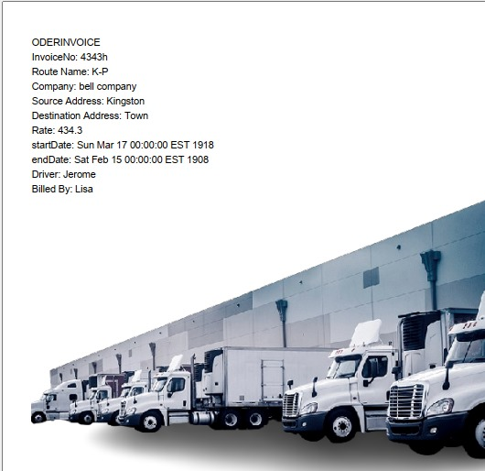

The Order Invoice details as follows:

* Invoice No: 4343h
* Route Name: K-P
* Company: Bell Company
* Source Address: Kingston
* Destination Address: Town
* Rate: $434.3
* Start Date: Sunday, March 17, 1918
* End Date: Saturday, February 15, 1908
* Driver: Jerome
* Billed By: Lisa

This Order Invoice captures essential information regarding a specific transaction within the JAVA Haulage and Trucking (JHT) system. The invoice number uniquely identifies the transaction, while the route name, company name, source, and destination addresses delineate the transportation route and involved parties. The rate denotes the monetary amount associated with the transaction. The start and end dates specify the duration of the order, with the assigned driver indicated for accountability. Lastly, the invoice is billed by Lisa, signifying the administrative staff member responsible for processing the transaction.

**Figure 8. Generate Report Window**

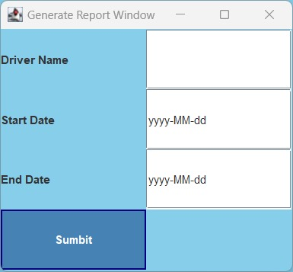

The Generate Report Window provides a user-friendly interface for administrative staff within the JAVA Haulage and Trucking (JHT) system to generate reports based on specific criteria. This window features input fields for the following parameters:

* Driver Name - Allows administrative staff to specify the name of the driver for whom the report will be generated.
* Start Date - Enables administrative staff to input the start date of the time period for which the report will cover.
* End Date - Allows administrative staff to input the end date of the time period for which the report will cover.

Additionally, the window includes a "Submit" button, which triggers the generation of the report based on the specified criteria. Upon clicking the "Submit" button, the system processes the input parameters and generates a comprehensive report detailing relevant information such as trip details, earnings, or performance metrics for the specified driver within the designated time frame.